**Page Header**

At the top of the page is the header element. On larger screens we will show a cool background image, but on smaller mobile screens we will use a gradient fill so that it renders quickly and doesn’t consume data bandwidth.

[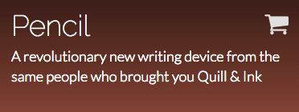](https://faculty.washington.edu/dlsinfo/info343/responding-style/header-sm.png)

Page header on narrow mobile device screens.

[](https://faculty.washington.edu/dlsinfo/info343/responding-style/header-lg.png)

Page header on screens 992 pixels and wider.

Add the elements necessary for this page header. A few tips:

* All of the text should be constrained in width so that it doesn’t get too wide on large desktop monitors. Use the container style class from Bootstrap to do this.
* The “Pencil” text should be a level 1 heading, and the other text should be a normal paragraph.
* The [shopping cart](http://fontawesome.io/icon/shopping-cart/) icon comes from the font awesome icon font, which is already added to your page. Surround it with a hyperlink so that when it’s clicked, the browser navigates tohttps://amzn.com/B0188A3N16. Since it doesn’t have any text on narrow screens, you should include an [aria-label](https://developer.mozilla.org/en-US/docs/Web/Accessibility/ARIA/ARIA_Techniques/Using_the_aria-label_attribute) attribute that describes what the link points to.
* The “Get Yours Now” button should actually be a hyperlink element, also pointing to https://amzn.com/B0188A3N16. Use CSS formatting properties to make it look like a button.

Then add the style rules so that your content matches the screen shots above. A few specifics you will need:

* On small screens, the header background should have only a linear gradient fill. The gradient should start with the color #391D18 at the top, and fade into #814236 at the bottom.
* On screens 992 pixels and wider, the background should switch to using the image img/header.jpg. It should cover the entire background of the header element, and be [positioned](https://developer.mozilla.org/en-US/docs/Web/CSS/background-position) so that it remains centered horizontally, but at the bottom of the image vertically.
* Although the “Get Yours Now” button is a hyperlink element, your styling rules should make it look like a button, as shown in the screenshot. The background color should be #814236 and the border color should be #391D18.

|  |  |
| --- | --- |
| The next section displays four feature “cards” for this new device in a responsive grid layout. Each card includes an icon, a title, and some descriptive text. The layout adjusts as follows:  <https://faculty.washington.edu/dlsinfo/info343/responding-style/features-sm.png>  Features section on narrow mobile device screens.  <https://faculty.washington.edu/dlsinfo/info343/responding-style/features-md.png>  Features section on screens 768 pixels and wider.  <https://faculty.washington.edu/dlsinfo/info343/responding-style/features-lg.png>  Features section on screens 992 pixels and wider. | **Features Section**  Add the elements for the features section of the page. A few tips:   * All of the content in this section should be constrained in width so that it doesn’t get ridiculously wide on large desktop monitors, but the background color of the entire section should still extend all the way to the edge of the browser window. Make use of the container style class already defined for you in css/style.css. * The “Packed with Features” text should be a level 2 heading, while the feature titles should be level 3 headings. * The icons are in the svg sub-directory. Copy and paste the contents of those SVG files into your HTML page so that you can style them (you can’t adjust their colors if you use an <img>element that points to the SVG file). Later in the course I will show you how to use a tool like gulp to do this insertion of content during an automated build step. * Use an HTML symbol entity for the [registered trademark symbol](http://www.rapidtables.com/web/html/html-codes/html-code-tm.htm), and make it superscript text.   Add style rules so that your content matches the screen shots above. A few specifics you will need:   * The section background color should be #F8F8F8. * The “Packed with Features” text should be in [small-caps](http://www.w3schools.com/cssref/pr_font_font-variant.asp). * The color of the icons should be #814236. Note that the CSS property that controls the color of SVG elements is not the same one that controls the color of text. * The color of the border around each feature card should be #DFDFDF and the corners of the border should be [rounded](https://css-tricks.com/almanac/properties/b/border-radius/) by 3px. * The background color of each card should be white. * On narrow mobile screens, the feature cards should be stacked on top of each other, with the feature icon on the left, as shown above. * On screens 768 pixels and wider, the cards should be in a 2x2 layout, and the icons should appear on top of the feature title. * On screens 992 pixels and wider, the cards should be in a 1x4 layout. |

**Uses Section**

The next section describes a few uses for this revolutionary new device. Like the section above, these cards are in a responsive grid layout, but they also have images at the top of each card.

[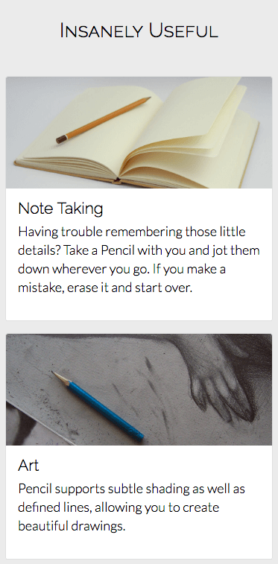](https://faculty.washington.edu/dlsinfo/info343/responding-style/uses-sm.png)

Uses section on narrow mobile device screens.

[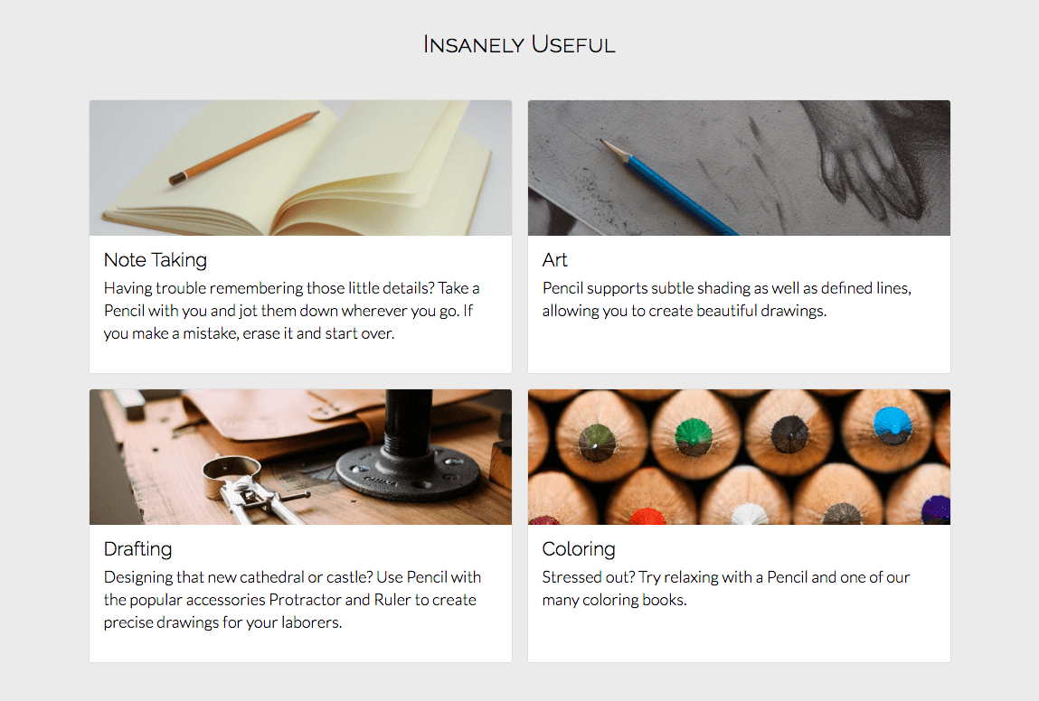](https://faculty.washington.edu/dlsinfo/info343/responding-style/uses-lg.png)

Add the elements for this section of the page. A few tips:

* All of the content should be constrained in width so that it doesn’t get ridiculously wide on large desktop monitors, but the background color should extend to the edges of the browser window.
* You should use the same style classes you used for the feature cards on these usage cards. They should have the same border color, rounded corners, and background color.

Add style rules so that your content matches the screen shots above. A few specifics you will need:

* The section background color should be #EBEBEB.
* The various images are in the img sub-directory. Each image should cover the top part of the card and be 150 pixels tall.
* On narrow mobile screens, the usage cards should be stacked on top of each other.
* On screens 992 pixels and wider, the layout should become a 2x2 grid, as shown above.

**Testimonials Section**

Following the grand tradition of marketing sites, the next section contains testimonials from happy users. These are also displayed in a responsive layout. Next to each testimonial is a rounded profile picture.

[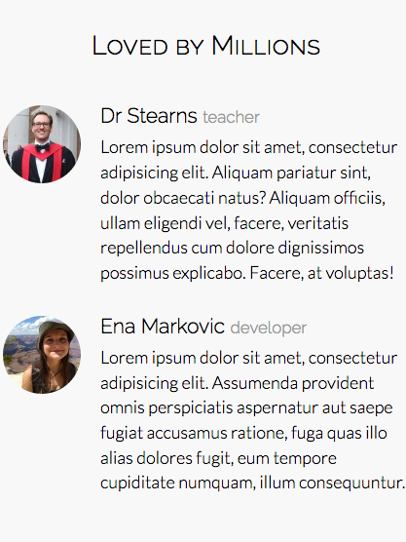](https://faculty.washington.edu/dlsinfo/info343/responding-style/testimonials-sm.png)

Testimonials section on narrow mobile device screens.

[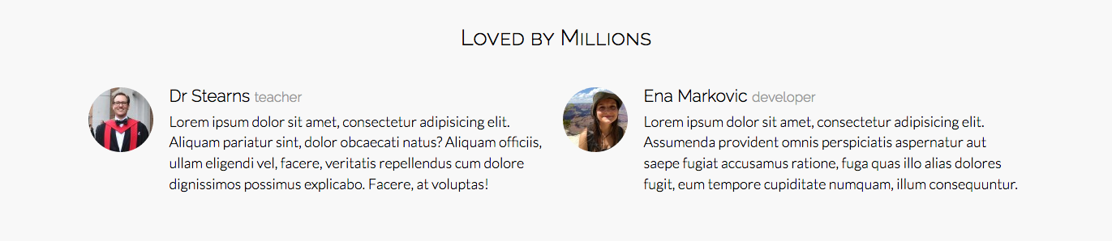](https://faculty.washington.edu/dlsinfo/info343/responding-style/testimonials-lg.png)

Testimonials section on screens 768 pixels and wider.

Add the elements for this section of the page. A few specific requirements and options:

* All of the content should be constrained in width so that it doesn’t get ridiculously wide on large desktop monitors, but the background color should extend to the edge of the browser window.
* The first image should come from https://www.gravatar.com/avatar/0e58cf2f03c9a0a5d6965154837cd595. The second should come from https://www.gravatar.com/avatar/71900224a10dd5cb3f230f9f64eeaf43. If you’re feeling adventurous, create your own [Gravatar](https://en.gravatar.com/) account, upload your own profile picture, and use it instead. See [their API](https://en.gravatar.com/site/implement/images/)for details on the URL format. To get the MD5 hash for your email address, use this [MD5 generator site](http://www.miraclesalad.com/webtools/md5.php).

Add style rules so that your content matches the screen shots above. A few specifics you will need:

* The section background color should be #F8F8F8.
* The person’s name should be in normal black text, but their title should be only 80 percent as tall and in the color #999999.
* The profile picture should appear to the left of the name and text, as shown above.
* The profile picture should be [rounded into a circle](https://css-tricks.com/almanac/properties/b/border-radius/), even though the original image is a rectangle.
* On narrow mobile screens, the testimonials should stack on top of each other.
* On screens 768 pixels and wider, they should appear side-by-side.

**Footer**

At the bottom of the page is the footer, which traditionally contains copyright and attribution information, along with a set of contact links.

[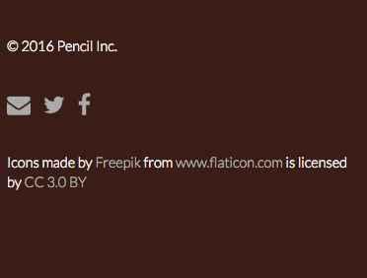](https://faculty.washington.edu/dlsinfo/info343/responding-style/footer-sm.png)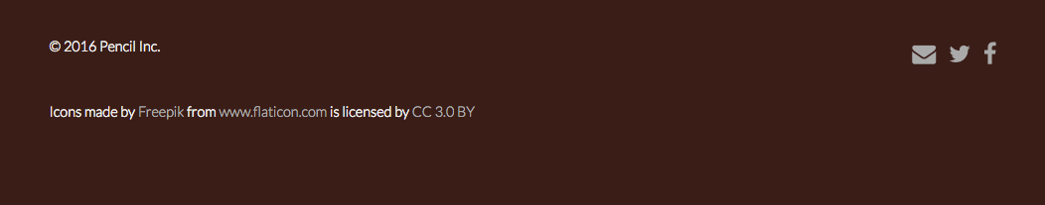

Page Footer section on screens 768 pixels and wider.

Add the elements for this section of the page. A few notes:

* The copyright symbol should be added using an HTML symbol entity.
* The contact link icons are from the Font Awesome icon font. From left-to-right, they are:
  + [envelope](http://fontawesome.io/icon/envelope/): should be surrounded by a hyperlink that when clicked starts a new email message addressed to info@pencil.com.
  + [twitter](http://fontawesome.io/icon/twitter/): should be surrounded by a hyperlink that when clicked navigates to https://twitter.com/pencilorg.
  + [facebook](http://fontawesome.io/icon/facebook/): should be surrounded by a hyperlink that when clicked navigates to https://www.facebook.com/search/top/?q=pencil.Since these icons have no text that a screen reader can read, add aria-label attributes to them. The text in that attribute will be spoken by the screen reader when the user tabs to the surrounding hyperlink.
* Use this for the attribution text:
* <p>Icons made by
* <a href="http://www.freepik.com">
* Freepik
* </a>
* from
* <a href="http://www.flaticon.com">
* www.flaticon.com
* </a>
* is licensed by
* <a href="http://creativecommons.org/licenses/by/3.0/">
* CC 3.0 BY
* </a>
* </p>

Add style rules so that your content matches the screen shots above. A few specifics you will need:

* The background color should be #391D18.
* The text color should be #EEEEEE.
* The hyperlink text color should be #AAAAAA and should [not have any underlining](http://www.w3schools.com/css/css_link.asp), even when you hover over the hyperlinks with a mouse.